Project Charter
Brownfield Redevelopment Project

The Dream Team (Group 1)
October 19, 2018

Foundations of Project Management, PMAN 634
Bander Arnous
Kidst Asfaw
Gina Axarlis
Althea Barlow
Jephter Buahen

Nuclear Site Clean Up - Brownfield Redevelopment Project on Calvert Cliffs Nuclear Plan
Calvert Cliffs Nuclear Power plant is a nuclear power plant that was closed down in 2015. Located near the Chesapeake Bay in Lusby, Maryland, it was the only operating nuclear operating nuclear site in the state up until the time it was closed down. Brownfield, on the other hand, refers to site locations that were previously developed and used for a commercial or industrial purpose which are now abandoned and may be contaminated by hazardous contaminants.
The Brownfield Redevelopment Project is the cleanup and redevelopment process of these sites. Local governments and communities, as well as private investors, are faced with the task of improving these abandoned and sometimes contaminated sites. The Environmental Protection Agency (EPA) has a Brownfield program that provides assistance to various stakeholders in other to improve the environment.
Project Overview and Purpose

Brownfield sites refer to site locations that were previously developed and used for commercial or industrial purpose which are now abandoned and may be contaminated by hazardous contaminants. The Brownfield Redevelopment Project is the cleanup and redevelopment process of these sites. Local governments and communities as well as private investors are faced with the task of improving these abandoned and sometimes contaminated sites. The Environmental Protection Agency (EPA) has a Brownfield program that provides assistance to various stakeholders in other to improve the environment. Our project will seek to acquire funds from the EPA as part of their Brownfield program to clean up abandoned nuclear site known as the Calvert Cliffs Nuclear Plant in Lusby, Maryland

Our project will seek to acquire funds from the EPA as part of their Brownfield program to clean up abandoned nuclear site known as the Calvert Cliffs Nuclear Plant in Lusby, Maryland.
Project Scope Statement
The key milestones within the project boundaries are acquiring funds for the project, most importantly cleaning up the nuclear site and redeveloping these sites.
Project Objectives
Our project will seek to acquire funds from the EPA as part of their Brownfield program to clean up abandoned nuclear site known as the Calvert Cliffs Nuclear Plant in Lusby, Maryland.

Project objectives and success criteria
- Assess the amount of radiation traces in the environment.
- Evaluation of the degree of risk/threat of the radiation remnant
- Safety cleanup of the radiation traces.
Project Deliverables
The Brownfield Redevelopment Project was largely a successful activity because it surpasses its performance metric. The three critical success parameters that influenced the operationalization of the cleanup and redevelopment projects include the assessment of the amount of radiation traces in the environment, evaluating the degree of risks from the existing radiation remnants, and instituting a sustainable clean-up activities. Specifically, the project yielded four deliverables and five work-packages.
The respective project deliverables are listed as the following outputs;-
- Need Assessment Plan
A successful project implementation hinges on the efficient level of preparedness to facilitate the project manager establish a robust roadmap. A team-based deliberation was an essential safeguard to improve the robustness of the plans and inclusivity. An open discussion approach ensured diverse needs were taken into considerations (Snyder, 2013). The Need Assessment Plan Deliverable further entailed three work packages, which focus on human resource requirements, equipment and machinery, as well as financial planning. Importantly, the review of equipment and machineries guarantee provision of appropriate protective gears as well as heavy machineries to save on time. The machinery assessment satisfied the company had adequate capital infrastructures to undertake satisfactory radiation cleanup and redevelopment activities in the Chesapeake Bay and Brownfield regions.
However, a Human Resource (HR) plan revealed that the company faces a significant gap in the number of the environmental cleaning technicians. The proposed human resource plan stipulated the need to recruitment of five (5) consultants with expertise in nuclear cleaning, 10 cleaning technicians, and 20 local non-skilled volunteers. Further, the company resolution to prioritize the local labor market was a strategic intervention because it attracted support from the community and instill a sense of ownership. Recruitment of local and non-skilled labor force further led to another work-package that relate to training manual to minimize accidents and breach of safety preparedness.
Lastly, a financial plan was an essential work-package because it sought to ensure continuous implementation. The financial plan deliverable entailed three key work-programs that aided in attaining the budgetary requirement, accountability, and value for the money invested. Notably, a project proposal had been developed and forwarded to the chief sponsor that included the Unite State Environmental Protection Agency (EPA). The company succeeded in receiving the grant of $1,940,000, which constitute 97% of the entire budgetary requirements. The remaining balance of $60,000 was sourced from the donation and proceeds from two successful dinner galas. Equally, the financial plan stipulated formation of two ad hoc committees to oversee implementation of the budget and serve as an investor liaison during the project implementation phase as well as hand-over period.
- Operational and Risk Assessment Plan
Implementations of nuclear site cleanup projects are complex and risky activities because of the myriad regulatory frameworks as well as multiple hazards. The Operational and Risk Management Plan provides an efficient roadmap to mitigate adverse threats that were likely to increase the operation constraints. The respective work-package modules focused on achieving a proactive management because of the need to trace the existing radioactive deposits in the sites before the commencement of cleanup and redevelopment activities. The three radioactive materials identified were the enriched uranium deposits, contaminated low-level components, and deposits of spent pellets of nuclear fuels.
Similarly, an assessment of the degree of risk from radioactive remnant was a strategic work-program that sought to ensure minimum exposure during the cleanup and redevelopment phases. A multidimensional team was tasked to devise appropriate storage systems to eradicate future contamination and the exposure threats. The team further concluded the primary risk inherent in the operation was an exposure to nuclear radiation because of high probability-impact coefficient of 12. The team also recommended a regular review of the technologies because inefficiencies could alter the metrics and overall effectiveness of the project. Another note end from the risk evaluation report considered the regulatory risk to be a core constraint because of the rapid changes of government laws and regulations.
- Cleanup Criteria
Successful operational and risk assessment deliverable was essential toward the outcome of the cleanup and redevelopment activities. Moreover, the subsequent removal and storage of three radioactive materials enhanced employment of semi-skilled and non-skilled local labor during the cleanup activity. Specifically, five cleanup teams were established and participants assigned to the respective team. The cleanup processes focused on the surrounding water bodies, existing agricultural projects, and assessment of the aquatic microorganism to prevent animal-to-animal contamination in the future.
- Redevelopment of the Brownfield Site
The benefits of redeveloping the Brownfield extend beyond the monetary values because it entailed among other goal to enhance conservation of environment and creating employment opportunity to the local communities. The profound programs instituted to initiate sustainable development include provision of two new water treatment units to improve the safety of drinking water. A cancer and recovery center was established to improve the quality of healthcare in the region because of the high prevalence of cancerous-related complications. Equally, an innovation and incubation center was also enacted to nurture new economic opportunities.
Projects Requirements
- There is a need to bring on board scientists who are expert in the field of nuclear science to help us assess the situation.
- There is also a need for advanced cleaning technology that will be used in riding off the radiation remnants.

There is a need for hiring cleaning technicians. These technicians will be trained and equipped with tools to clean up the nuclear residues.
Source of labor
The company resolved to prioritize the local labor market to close the HR requirement gap and instill a sense of ownership. Recruitment of local and non-skilled labor force further led to another work-package that relate to training manual to minimize accidents and breach of safety preparedness. The company recruited 40 specialized and non-specialized labor forces to facilitate the attainment of four project deliverables.
- Five (5) environmental specialists with extensive knowledge and skills in nuclear site cleanup
- Fifteen (15) cleaning technicians
- Twenty (20) non-skilled volunteers assigned to various cleanup teams headed by skilled technicians
Project Milestones
Key Milestone | Start Date | End Date
Project Kick-off | 1 Oct 18 | 20 Oct 18
Business Requirement | 20 Oct 18 | 1 Nov 18
Assess the amount of radiation traces in the environment | 2 Nov 18 | 3 Mar 18
- Background radiation | 2 Nov 18 | 2 Dec 18
- Cosmic radiation | 3 Dec 18 | 10 Jan 19
- Radioactive Materials in the Earth and in Our Bodies | 11 Jan 19 | 5 Feb 19
- Man-made Sources | 6 Feb 19 | 3 Mar 19
Evaluation of the degree of risk/threat of the radiation remnant | 4 Mar 19 | 17 Oct 19
- Hazard identification | 4 Mar 19 | 7 Jun 19
- Estimation of dose-response relationship | 6 Jun 19 | 1 Jul 19
- Exposure assessment | 2 Jul 19 | 26 Sep 19
- Risk characterization | 27 Sep 19 | 17 Oct 19
Safety clean-up of the radiation traces | 18 Oct 19 | 20 Feb 21
- Cleanup criteria | 18 Oct 19 | 20 Jan 20
- Co-operative agreements | 21 Jan 20 | 1 Jun 20
- Methods and equipment to implement the cleanup | 2 Jun 20 | 20 Dec 20
- Radiological safety and protection plan | 21 Dec 20 | 20 Feb 21

Table 1 above depicts the summary of the profound milestones and the projected time duration. The commencement date for the project is October 1 2018 with an estimated date of closure being 20 February 2019. The time duration stipulated is a tentative period aimed to influence the strict compliance with the project timetable. A contingency plan entails an addition of maximum 7-days beyond the estimated date of closure.
Project Assumptions, Constraints, Risks and Concerns
The key milestones within the project boundaries are acquiring funds for the project, most importantly cleaning up the nuclear site and redeveloping these sites. High-level requirements include alignment with government regulations, obtaining advanced technology for detecting radiations, hiring scientists and technicians, and ensuring safety measures for cleaners.
A major assumption is the possible outcomes from investments in brownfield redevelopment due to the complex nature of improper documentation, the diversity of projects, and legislation.
Constraints, on the other hand, would revolve around government rules and regulations that require nuclear site clean-up organizations to meet their stringent standard of operations. Acceptance by the community and local government could be a constraint in case not all parties involved support the idea.

The overall project risks inherent in the project were listed as the following

The main and most dangerous risk associated with the operation is the risk of exposure to nuclear radiation.

Substandard available technology can alter metrics since the metrics will be determined by the technology being used despite being the technology being modern.

The regulatory risk here involves a change of government laws and regulations that standardize cleaning up the nuclear site and employment of local people.
Project Organization

Project manager and authority level
The project manager for this project is Jephter Buahen and his level of authority is expert. He has technical knowledge of the operation of this project and understands the full scope of the operation.

Project sponsor or customer and authority level
The main sponsor of this project is the EPA. The type of funding by this organization is a grant that comes from its special Brownfield redevelopment program for programs of this type. The EPA’s authority on this project is to oversee the safety of our operation and regulate it to ensure that project attains its goal with the standard safety requirements.
Work Breakdown Structure

Work-package

Deliverables

Project Title

Dream TeamProject: Brownfield Redevelopment

Need Assessment

Review of equipment

HR-Requirment Gap

financial plan

Operational & Risk Assessment

traces of radioactive remnants

Degree of Risk

Cleanup

cleanup criteria

redevelopment

new water treatment plants

cancer center

incubation center
Responsibility Assignment Matrix
RAM which also known as RACI (responsible-R, Accountable-A, Consulted-C, Informed-I)matrix of the Linear Responsibility Chart (LRC). RAM is used to describe the participation of the various departments in completing a project. It describes who is responsible to achieve a certain task, and the delegations made to make sure that the work is done on time.
Activities/tasks | Functions
Determine the risk management alignment | CEO | CFO | Business executive | CIO | Senior mgt. | Head Operations | Chief architect | Head Devlpt. | Compliance, risk and security, Audit
Determine the risk management alignment | A | R/A | C | C | R/A | I |  |  | I
Understand the relevant business policies |  |  |  | C | C | R/A |  |  | I
Identify the IT objectives and the risk context |  |  |  |  | R/A |  | C | C | I
Identify the events which are associated with the objectives | I |  |  | A/C | A | R | R | R | I
Assessment of the risks |  |  |  | A/C | A | R | R | R | C
Risk responses | I |  | A/C | A | R | R | R | R | C
Control activities | C | C | A | A | R | R | C | C | C
Funding for risk plans |  |  | A | A |  | R | I | I | I
Monitor the risk action plan | A | C | I | R | R | C | C | C | R
Determine the strategic objectives |  | C | C | R/A | C | C |  |  | I

Project Communications
Communication channels
  - Written and oral
This channel which is mostly done through written memos and a word of mouth is used to communicate the different interests and perspectives of the shareholders. Types of information include; memos about upcoming meetings and organization policies. This communication is frequent.
  - Email and google drive
This involves use of emails and google drive to share sensitive information about the project. This is more official and is commonly for the subordinates and the bosses. They can also use reports and briefings shared on email or google drive. The communication is frequent and urgent.
  - Telephone
Used in geographically dispersed areas to share information through voice and text. This communication is often and used only when it is necessary.
Tracking plan
The following is a guide/plan which will be used to track the project milestone
      - Determine the work done
The project management team can evaluate the work done/milestone quarterly or yearly. Work break down structure is then provided for each project done
      - Determine the resources needed
How much time is needed to complete will be determined at each evaluation. All the expenses and travel costs must be planned for as well as the money spent.
      - Compare the work done and the resources spent
The project management team will compare the milestones and the set objectives. This will include project auditing.
      - Track milestones
Communications management matrix below.
The following are various dimensions used in the communication to run the project
Method of communication | When used
Formal and written | Project documentation, contractual issues, use of emails
Informal, Oral | Conversations e.g. during meetings
Formal, Oral | Speeches, some meetings and presentations
Informal, written | Memos, notes, emails

Project Schedule
The following is both a grant and a CPA for the project. In the grant chart, the project will be broken into 4quarters.
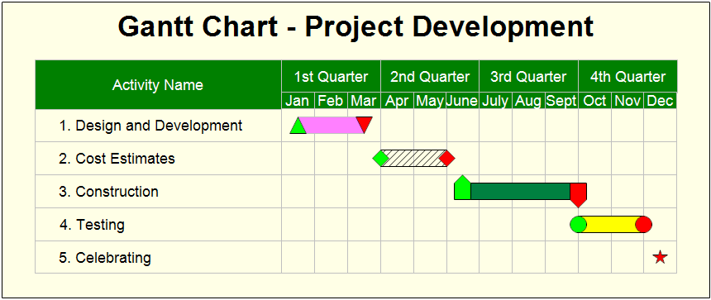
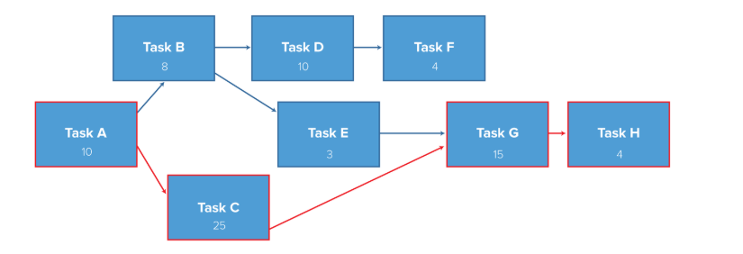

Project Gantt Chart
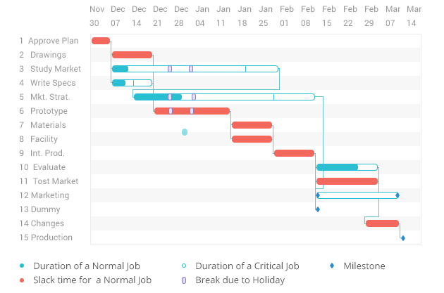
The purpose of the grant chart is to maintain the project and accomplish the various sub-projects in time to enhance the ultimate goal of the general project. The grant chart helps in scheduling and keeping the project’s workflow in order to meet the deadline as well as improve performance. It helps in identifying the milestones, splitting goals and tracking the progress of the project. Generally, the grant chart will help the team to track and evaluate progress.
Project Critical Path
The team will use CPA as a guide to accomplish the project in a smooth network that will transition from one project to the next. The following I a caption of the testing stage which will take an approximate of 10days to complete.
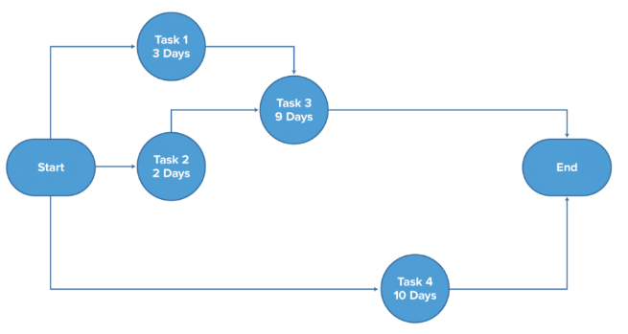
Project Budget
The method used to determine the costs is the bottom up method. The allocation of resources is done depending with the time allocated for the project and the quality of the project and the estimated cost of the materials.
Funding | Budget | Actual | Difference
Department budget | $90,000 | $50,000 | $40,000
Customer Billing/invoicing | $20,000 | $10,000 | $10,000
Existing revenue streams | $100,000 | $80,000 | $20,000
Direct and indirect costs | $50,000 | $30,000 | $20,000

Project Risk Management
The process of risk management will involve the following steps
- Identify the risk
This involves identifying the risk through its occurrence probability, major damages it can cause and when it can happen. Each risk should be graded by the risk response team
- Assess risk
The risk is assessed in terms of its impact/seriousness, probability/likelihood and ranked as low or high etc.
- Response to the risk
This involves development of action plans and options to reduce threats. This involves updating of the risk register and the project management plan
- Control risk
- Take the corrective measures
- Validate risk mitigation alternatives
- Ensure the change control proposes the change needed.
Risk Identification
The risk management team will identify the most likely risks that will affect the project outcome and put them in the risk register. This process will involve the use of checklist that will identify the potential risks that will evaluate the likelihood of the risk happening and how it will affect the completion of the project. The method of risk evaluation will involve identifying the specific risks based on the past experience. The risk will them be categorized under the following areas namely;
        - Cost
        - Client
        - Technical
        - Weather
        - People
        - Environmental
        - Political
        - Financial
This method is appropriate because it has a well-developed risk breakdown structure that is well organized and identifies the risks at an early stage before it becomes enormous and at this point the risks can be categorized and the correct action taken.
Risk | Description
Personal risk | This includes the loss of life caused by injury harm. For example, a person gets injured while at the place of work
Property risk | Involve the loss to property caused by fire. Property can also be damaged or get obsolete. E.g. equipment
Climate risks | Involves damages caused by floods or weather conditions. When natural risks caused by change in climate occur, they cause loss of property or life.

Risk Assessment
The organization will group the risk in accordance with its impact or consequence to the organization. This will be graded with a scale of 1-5 with 1 being the lowest level or less the risk is likely to occur or its effect to the organization is less. This can also be translated to a percentage with 1 being 10% and 5 converted to 100%. This scale is key in essential in illustrating the impact of the risk as well as its likelihood to occur as indicated in the diagram below;
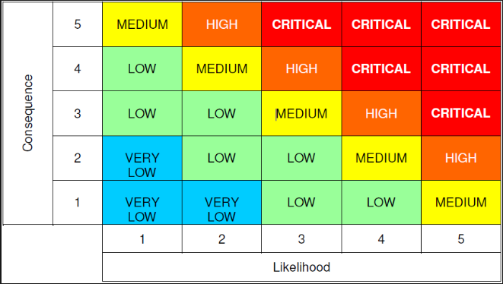
Risk Response
Risk identified | Description
The following are risk responses which can apply in case of a risk to property, or employees. | Response team that can deliver first Aid to people injured when a risk occur. For example, physical injury.
 | It is important to ensure that all the risks are insured against. For example insure property to avoid total loss caused by fire. On the other hand, it is important to set up a team to assess risks that could lead to loss of property. On the other hand, what can be done in case the risk occurs? e.g. actions to ensure business continuity.
 | To involve a disaster recovery plan to enhance continuity of business. The business should not stop just because a risk has occurred. E.g. floods, the business should have another point where it can operate efficiently.
 | In response, the organization should have a good security system e.g. surveillance and security. When property is secured, more damage will be prevented in the future.
 | Conduct a risk assessment that will uncover the cause and effect. This will involve clearing exercise. For example, in case of spillage of hazardous substance which could kill aquatic life.

Risk Monitor and Control
The organization will ensure;
        - Ensure that all the execution of the risk plans is done in order to evaluate the effectiveness and reduce risks involved
        - Keep a track of all the identified risks for example the watch list
        - Monitor the trigger conditions needed for contingencies
        - Update the assets used/owned by the organization
        - Risk responses are identified and implemented
Project Evaluation
Project evaluation is a critical activity in a project management because it aims to enhance proactive analysis of environmental variables that influence the overall performance. Therefore, the Dream Team strives to undertake regular project evaluations at various strategic points that include before, during, and after the closeout stage (Snyder, 2013). The need assessment is a model of a pre-evaluation process that merited because it determines the level of preparedness before undertaking the cleanup and redevelopment projects. For example, the use of multidimensional team to undertake pre-evaluation revealed the existence of human-resource requirement gaps and availability of adequate equipment.
The on-going project evaluations entail assessing the level of project performance using multidisciplinary teams (Snyder, 2013). Four on-going project evaluations have been estimated to undertake during the project implementation. Notably, a multidisciplinary team met upon the achievement of each deliverable. Therefore, four evaluations were undertaken to consider the effect of Need Assessment Plan, Operational and Risk Assessment Plan, Cleanup Criteria, and Redevelopment process.
Project Close-out
The following are the major activities that need to be completed to close or terminate the project.
        - Ensure all the documents and the deliverable are updated and if any issue has raised is resolved
        - Close all the project accounts
        - Confirm the acceptance and the delivery of the customer
        - Reassign personnel i.e. the project employees can take up another contract
        - Deal with the excess material such as sand, bricks, wood etc.
        - Reallocate all the project equipment and facilities
        - Administrative closure which will ensure that hand over of the project deliverables to the next responsibility center
        - Financial closure which will ensure all the transfer of the remaining funds is done.
Lesson learned
This section will identify the major successes and all the challenges encountered during the project such as leadership challenges. A description of the project and the project documentation will be made available. Information will be shared at the departmental, and branch levels.

References
Bowling Green State University (2015) PeopleSoft road map-CSS/HCM split project: Project
Charter. Retrieved from https://www.bgsu.edu/content/dam/BGSU/ITS/documents/tech-topics/peoplesoft/split_project_charter.pdf
Horton, S. (n.d.) Developing a project charter. Retrieved from https://webstyleguide.com/wsg3/1-process/8-project-charter.html
Pearce, F. (2018, May 28). The 60-Year Downfall of Nuclear Power in the U.S. Has Left a Huge Mess. Retrieved from, www.theatlantic.com/science/archive/2018/05/the-60-year- downfall-of-nuclear-power-in-the-us-has-left-a-huge-mess/560945/
Snyder, C. (2013). (fifth edition). A project manager's book of forms: A companion to the PMBOK guide, Hoboken, N.J: Wiley.
Appendix A – Project Charter
Project Charter

General Information

Project Title |  |  |  | Date
Brownfield Redevelopment Project |  |  | 7/12/2018
Project Manager | Phone |  |  | Email
John Muller | 415.476.2821 |  |  | Muller@ucsf.edu
Executive Sponsor | Phone |  |  | Email
Opinder Jackson | 415.502.4004 |  |  | OP@medsch.ucsf.edu
Document Version |  | Updated Date
1.0 |  | 15/12/2018


Project Scope

Situation / Problem / Opportunity

Nuclear Site Clean Up - Brownfield Redevelopment Project on Calvert Cliffs Nuclear Plan

Project Goals

The Brownfield Redevelopment Project is the cleanup and redevelopment process of these sites

In Scope / Out of Scope

In Scope

The Brownfield Redevelopment Project is the cleanup and redevelopment process of these sites. Local governments and communities as well as private investors are faced with the task of improving these abandoned and sometimes contaminated sites.

Appendix B – Risk Register
Risk | Likelihood | Rating | Consequence | Risk assessment | Response strategy
Personal risk | Possible | Medium | Minor | This includes the loss of life caused by  injury harm | Response team that can deliver first Aid
Property risk | Possible | Low | Major | Involve the loss to property caused by  fire | Insure property to avoid total loss caused by fire. Set up a team to assess risks that could lead to loss of property
Climate risks | Possible | Low | Major | Involves damages caused by floods or  weather conditions | To involve a disaster recovery plan to enhance continuity of business
Criminal activity | Possible | High | Major | Burglary can put the organization at  risk. E.g. money is stolen | In response, the organization should have a good security system e.g. surveillance and security personnel
Contamination caused by chemicals | Possible | High | Major | Involves contamination of the rivers,  air with poison or untreated effluent | Conduct a risk assessment that will uncover the cause and effect. This will involve clearing exercise.

Appendix C – Project Close-out Checklist
Close out check list/items
• Ensure all the documents and the deliverable are updated and if any issue has raised is resolved
• Close all the project accounts
• Confirm the acceptance and the delivery of the customer
• Reassign personnel i.e. the project employees can take up another contract
• Deal with the excess material such as sand, bricks, wood etc.
• Reallocate all the project equipment and facilities

